Title: | HART – Layer 2
References: | HCF_SPEC-81, Revision 8.0 Data Link Layer Specification  HCF_TEST-1, Revision 2.1 Slave Data Link Layer, Test Specification
Distribution | Software Archive
Author MWME Heiko Kresse Date: 2005-09-05

Approved see Review Document

Remarks:

Contents

1 Context 3
2 Brief Description 3
3 Data Sheet 3
4 Detailed Description 5
4.1 Static Modelling 5
4.2 Dynamic Modelling 6
4.2.1 Transmit 6
4.2.2 Receive 7
4.2.3 BURST-Mode 8
4.3 Error-Handling 9
4.3.1 Design and Implementation Errors 9
4.3.2 Runtime errors 9
4.4 Dependencies to other Modules 9
4.5 Class Design 9
4.5.1 Privat attributes 9
4.5.2 Public attributes 10
4.5.3 void Initialize_LAYER2(void) 10
4.5.4 TBOOL AskIfLayer7requested_LAYER2(void); 10
4.5.5 void ClearLayer7request_LAYER2(void); 10
4.5.6 void StartResponse_LAYER2(void); 10
5 Revision Chart 10

Context
This Document is a representation of analysis, planning, implementation, and decision-making. It consists of design information for the subsystem <HART-Layer2>. One of its major goals is to support reuse of the described subsystem.

The document is divided into two main parts. First there is the data sheet in chapter one. This chapter is intended for developers that want to reuse the subsystem. Therefore it lists important issues from a black-box view. The second chapter describes the design in more detail. This is the right place to look for developers that have to maintain or expand the subsystem.

Besides this document, there are a couple of other documents that describe the requirements, test cases and the complete system the subsystem is used in. Links to those documents can be found at the end of the data sheet.

Brief Description
For this document it is necessary to be familiar with the Data Link Layer Specification (HCF_SPEC-81, Revision 8.0) and the Slave Data Link Layer Test Specification (Revision 2.1).
The module encapsulates all functionality for a HART-Slave-Data-Link-Layer (Layer2) with burst capability. An UART and a hardware-timer are used, thus for reuse on other platforms it is necessary to use the same processor, the same UART and the same timer. Otherwise it is necessary to rewrite some hardware related parts.
Another problem for reuse could be that this module was written for a platform with a very slow system-clock. So the BACK-frame for next burst will be generated during the sending of the actual BACK-frame. That means the burst-data are always older than 300ms! However, for most systems that should be no problem.

Data Sheet
This chapter gives an overview about all important facts of the subsystem.

Category | Item | Description
Development | Version / Status | 1.0 / implemented; module tested; lint level 3 free
Development | Known Bugs
Development | Planned Improvements
HW-Platform | Type | M16C (-28, -62)  (Useable for all processors with an UART and a timer (SW or HW))
HW-Platform | Clocking | >1MHz
SW-Development Environment | Compiler | IAR M16C/C++ Compiler Version 2.12E
SW-Development Environment | Operating System | -
SW-Development Environment | Case / Code-Generation Tool
Required Resources | Operating System
Required Resources | HW | UART2  Timer A1
Required Resources | RAM | 172 byte placed in STATIC_INTERRUPT_DATA
Required Resources | NVRAM | -
Required Resources | ROM | 48 Byte FARCONST  9 Byte interrupt vector table  3845 Byte CODE (no optimization)
Required Resources | Execution Time | average 300µs; max, ~1ms
Required Resources | Special HW
Required Resources | Subsystems | System.h for clock definitions  The memory segment STATIC_INTERRUPT_DATA defined inside the linker-command-file  LAYER1 – interface via method-calls  HART – Layer2 uses some objects of HART
Required Resources | Data Objects
Standards | Safety | This subsystem has to fulfill the safety standard SIL level 2.
Standards | Other
Documentation | Requirements / Use Cases | HCF_SPEC-81, Revision 8.0 Data Link Layer Specification
Documentation | Public Interface Description | layer2.h
Documentation | Test Specification | HCF_TEST-1, Revision 2.1 Slave Data Link Layer, Test Specification

Detailed Description

Static Modelling
The diagram 1 depicts the internal structure of layer 2, and the relationships to the other HART-modules. Layer 7 communicates via the interface-methods defined by class Layer 2, and some buffers of the type Hart-Buffer. The receiver-state-machine and the transmit-state-machine are encapsulated in the classes with the same name. Both state machines need some timer for their scheduling. Unfortunately the soft-timers offered by EMBOS are not able to fulfil the HART real time requirements. So the class/object “timer” offers soft-timers based on one hardware-timer.

Diagram 1
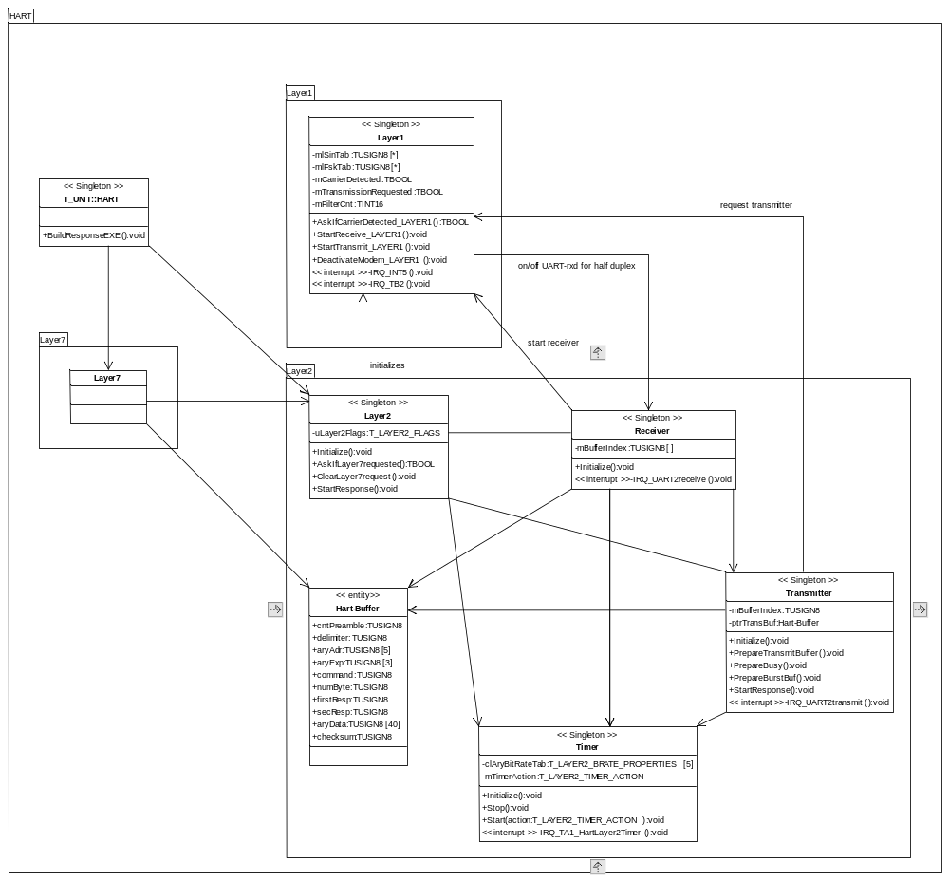

Dynamic Modelling
The dynamic model is mainly given by the HART-specification. Only for the BURST-Mode some special tricks are necessary to fulfil to hard real-time requirements.

Transmit
The transmit state-machine based on the HART-Spec-design (XMT_MSG Transmit State Machine), which hasn’t special handling for BURST-mode. Due limited computing power of RAINBOW some tricks are necessary to fulfil the real-time requirements of HART.
The time-lag between Burst-Frames (BACK), the Link Grant Time, is 73.34ms or 8 character times. RAINBOW is not able to generate the BACK-frame inside this time. So a prepared BACK will be send and during the sending of this frame the BACK for the next time will be generated.
To ensure correct bus arbitration the next or the first BACK must follow an ACK in less than 1 bit-time. In this case the BACK will be generated during the ACK transmission.

Diagram 2
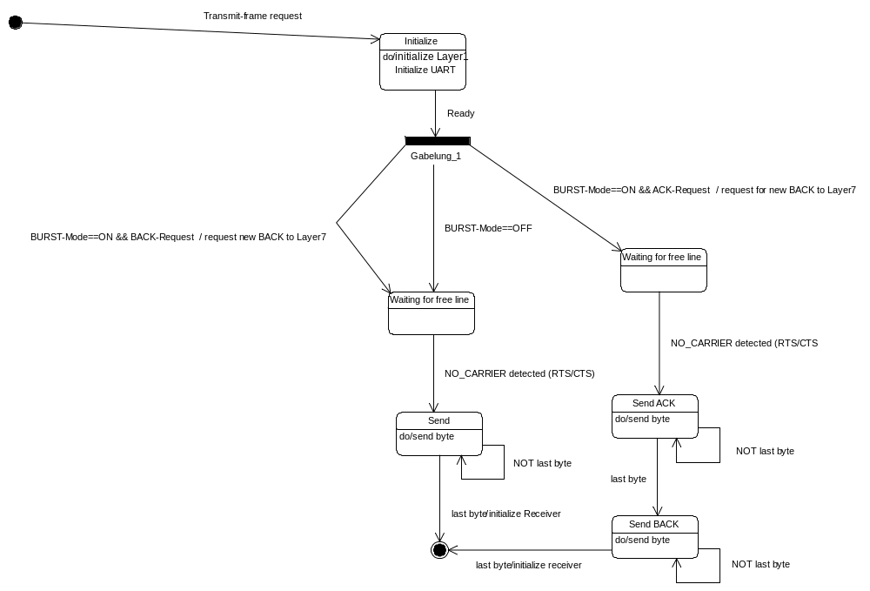

Receive
Diagram 3
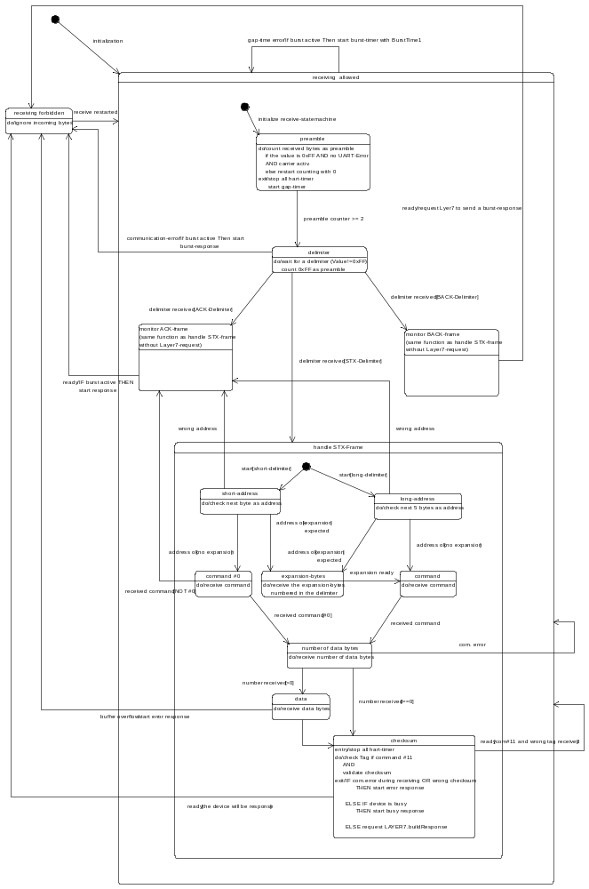
Diagram 3 shows the receiver state-machine that based on the Slave/Burst-Mode Device State Machine of HART. In addition to the HART-state-machine Diagram 3 shows not only the state handling at the end of a complete received frame but also the state-machine for receiving a frame.
The “Monitor”-states and the “handle STX frame”-state are the same, but “Monitoring” means that the frame will be ignored at the end and the receiver waits for the next frames. Unlike “Monitoring” the normal STX-handling will stop receiving and trigger layer 7 to generate an ACK.

BURST-Mode
The next diagram shows the interaction of Layer2 and Layer7 for BURST-mode.

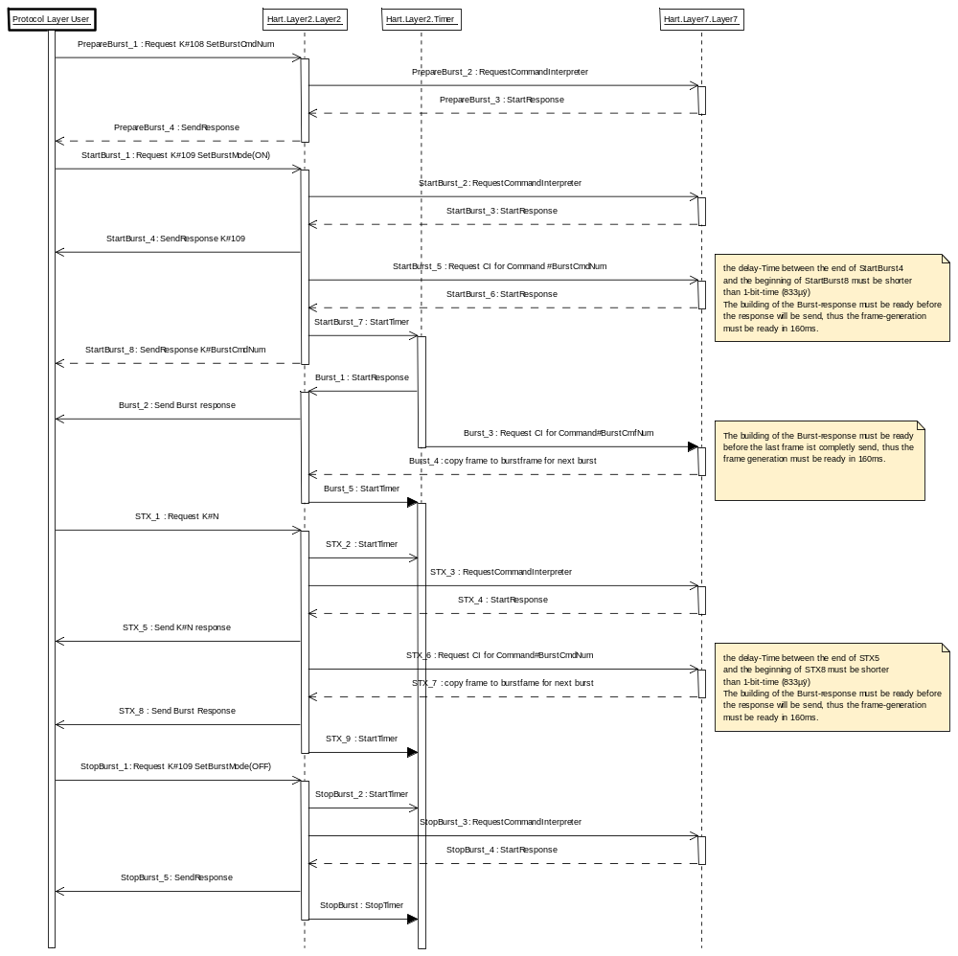

Error-Handling

Design and Implementation Errors
The strategy to prevent these errors is to avoid complex code and data structures.

Runtime errors
All possible external driven situations are part of the state machines (Diagram 2, 3).

An error in the used UART-hardware or Layer 1 stops the communication and will be detected by the Layer2-Timer. The timer-interrupt service routine will restart Layer2 and Layer 1, so the UART and Layer 1 will be initialized.

An error inside the Layer 2 state machines
- Stops the communication
The layer 2 timer will reinitialize Layer 2 and Layer 1
- Corrupts the received frame
The error will be detected via byte-count, the checksum or the Layer 2 timer. As a result the frame will be rejected.
- Damages the frame to be send
The bus-master will detect the error via byte-count, checksum or it gap-timer. The frame will be ignored.

Dependencies to other Modules
As shown in Diagram 1 Layer2 is Part of HART. That means also that Layer7 is a friend of HART and is allowed to access HART-data-objects directly. These objects are:
- hart_dynamic_data.bolDeviceIsBusy
- hart_static_frequent_static_default_data.burstModeSelectCode
- hart_static_frequent_static_default_data.numberRespPream
- hart_static_frequent_static_default_data.burstCmdNumber
- hart_static_frequent_no_default_data.pollAddr
- hart_static_frequent_no_default_data.tag
- hart_static_rare_data.bitRateCode
- hart_static_rare_data.deviceIdNumber

Class Design

Privat attributes
T_LAYER2_FLAGS uLayer2flags : flags for communication between timer, receiver and transmitter

typedef struct
{
unsigned char layer7requestedBit : 1; //!< TRUE --> responsecode has to be generated
unsigned char receiverActivBit : 1; //!< TRUE --> transmission not allowed
unsigned char masterAccessBit : 1; //!<
unsigned char burstAcknowledgeBit: 1; //!< TRUE --> monitored frame was a burst or acknowledge
unsigned char acknowledgeBit : 1; //!< TRUE --> mon. frame was an ack from another slave
unsigned char monitoringActivBit : 1; //!< TRUE --> only monitoring the actual frame
//!< function for K#109 response
} T_LAYER2_FLAGS;

Public attributes
//! structure used by transmitter and receiver
typedef struct
{
TUSIGN8 cntPreamble; //!< number of preambles to be send
TUSIGN8 delimiter;
TUSIGN8 aryAdr[5]; //!< devicde address
TUSIGN8 aryExp[3]; //!< expansion bytes
TUSIGN8 command;
TUSIGN8 numByte; //!< number of data bytes
TUSIGN8 firstResp; //!< first Response-Byte
TUSIGN8 secResp; //!< secound Response-Byte
TUSIGN8 aryData[40]; //!< data bytes
TUSIGN8 checksum; //!< Longitudinal XOR
} T_LAYER2_BUFFER;

T_LAYER2_BUFFER uTransmitBuffer_LAYER2;
Layer 7 copies the next frame to send into this buffer.

T_LAYER2_BUFFER uReceiveBuffer_LAYER2;
Layer 2 fills this buffer with the received frame.

void Initialize_LAYER2(void)
Initializes the UART-Hardware, the HART-Timer and calls the initialize of Layer 1.

TBOOL AskIfLayer7requested_LAYER2(void);
Returns TRUE if Layer 2 has requested a Layer 7 action. (build a response for the command number inside the transmit buffer.

void ClearLayer7request_LAYER2(void);
This method clears the request.

void StartResponse_LAYER2(void);
Layer 7 calls this function to start transmitting the frame in the transmit-buffer.

Revision Chart

Rev. | Description of Version/Changes | Primary Author(s) | Date
0.9 | First one | Heiko Kresse | 2005-02-25
1.0 | Release | Heiko Kresse | 2005-09-05
1.1 | Changes of data segment names (Chapter 4.4) | Horst Seele | 2006-01-19

